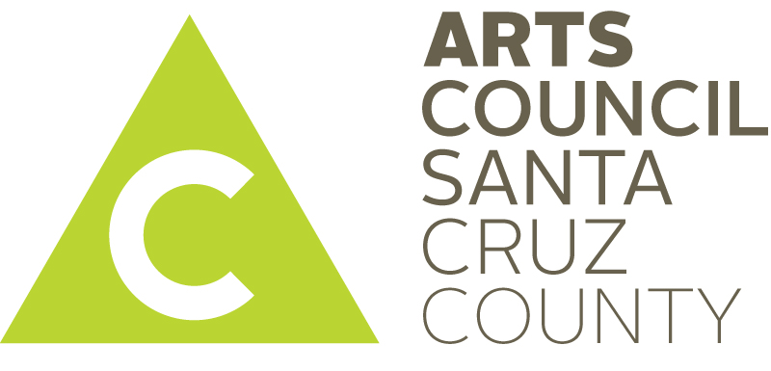
Robert Sward honored as Santa Cruz County Poet Laureate

SANTA CRUZ, CA — August 4, 2016 -Arts Council Santa Cruz County is pleased to announce the selection of Robert Sward as Santa Cruz County Poet Laureate.
Robert has taught at Cornell University, the Iowa Writers' Workshop and UC Santa Cruz. A Guggenheim Fellow he was chosen by Lucille Clifton to receive a Villa Montalvo Literary Arts Award. His more than 20 books include: Four Incarnations (Coffee House Press), Rosicrucian in the Basement, God is in the Cracks (Black Moss Press, Canada) and most recently, New & Selected Poems 1957-2011 (Red Hen Press).

His current work in progress, Love Has Made Grief Absurd, Gloria: A Monologue, is word-for-word in the voice of his wife, a visual artist struggling with Alzheimer’s.
“I delight in this community, for its natural beauty, its intellectual vigor, creativity and for its openness to both traditional and experimental poetry. I consider the Poet Laureate someone who, steeped in the local and national poetry scene, celebrates and serves poetry and the cultural life in his or her local community. I would like nothing more than to contribute to the poetry and literary legacy of Santa Cruz.” said Robert.
Robert will be inaugurated at the second annual Voices of the River, a family-friendly poetry event in San Lorenzo Park, 2:00 - 4:00 p.m., September 24th. The event is curated by Robert and is hosted by the Coastal Watershed Council and Poetry Santa Cruz with support from Arts Council Santa Cruz County and Bookshop Santa Cruz. Voices of the River is part of the Ebb & Flow River Arts Collaborative, which celebrates the vibrancy of Santa Cruz arts culture through the San Lorenzo River.
The Santa Cruz Poet Laureate works to increase awareness of poetry to both youth and adults. Robert plans to work with adults in assisted living during his tenure, “At age 82, I find myself thinking about legacy, and find myself inspired, too, by the example of my open-hearted and community-minded friends, James Houston and Morton Marcus. Following their example, I will endeavor to draw on my own 50 years of experience in teaching, writing, editing and publishing to give voice to this population of people who are so often silenced. I feel I have something to contribute to the imaginative and storytelling “youngsters” in their 50s, 60s, 70s and 80s.”

Robert Sward is Santa Cruz County’s fourth Poet Laureate, following Ellen Bass, Gary Young and David Swanger. The Poet Laureate serves a two year term and receives a small stipend to support his/her work. The program is sponsored by Arts Council Santa Cruz County, Poetry Santa Cruz, Santa Cruz County Office of Education and Santa Cruz Public Libraries.

Attachment: photo of Robert Sward and Cosette
