Created in Partnership among Santa Clara County Office of Education, Montalvo Arts Center, Santa Cruz County Office of Education, and Arts Council Santa Cruz County for use in Integrated Learning Curriculum Development.
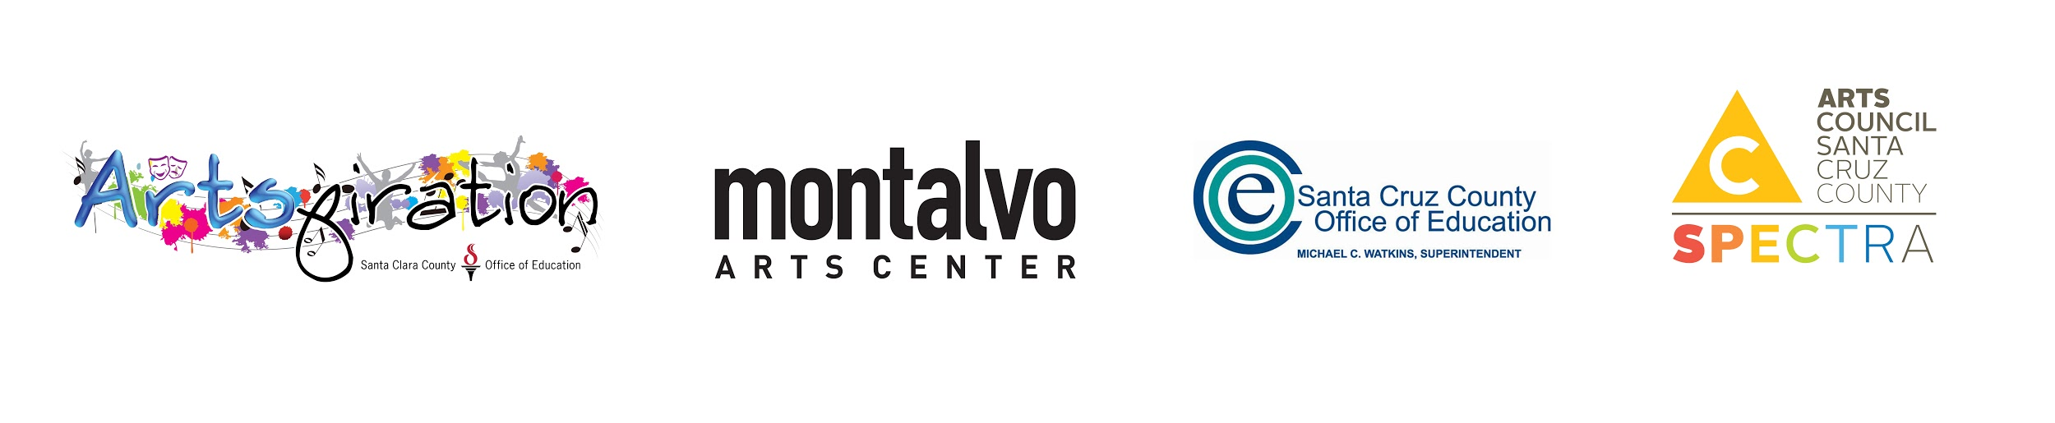
Artist Author: |  |  |  | Lesson Title:
Grades:
Art Discipline(s):
Art Standards:
http://www.nationalartsstandards.org/
Academic Content Area(s):
Common Core State Standards:
http://www.corestandards.org/ELA-Literacy/
Next Generation Science Standards:
https://www.nextgenscience.org/
Relevancy
(Cultural, Societal, Global, Local):
How is this relevant or important to the lives of students?
Lesson Overview
Brief Description:
Core Concept:
Understanding Goals:
(Essential Questions and Learning Outcomes)
What do I want my students to understand?

Integrated Habits of Mind:
Website
ILHoM Chart HYPERLINK "http://www.instituteforhabitsofmind.com/"
Studio Habits of Mind:
Studio Habits of Mind Chart
Growth Mindset:
Growth Mindset Chart
Growth Mindset Graphic
Depth of Knowledge:
Depth of Knowledge Wheel
DOK Chart
VTS, Arts History, & Discussion
VTS at a Glance
Are Other Pedagogies in Use? Please list:
Vocabulary:
Prep Time: |  |  |  |  | Lesson time:
Teacher Practice and Prep:
Include Tips & Precautions
Instructional Materials, Technology, and Equipment:
Resources/Bibliography/Source Credits:
Set-up Needs:
Procedures:
Please include accommodations for differentiated instruction
Critique and Reflection:
Performances of Understanding/ Assessment:
· Documentation
· Formative, Summative, Formal, and Informal
· 4 C’s Rubrics
4 C’s Lesson Design Aid

