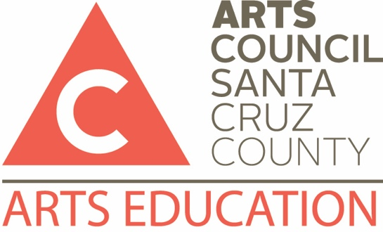
Teaching Artist Application
Visual, Literary and Performing Arts
Instructions
What you will need to apply | - An application form  The application includes a sample lesson plan on pages 3-5. Please copy and fill out this section for each proposed workshop or residency. You may submit multiple lesson plans, for example, one for “Introduction to Watercolors” and one for “Advanced Watercolor Techniques.”  - Résumé with three references.  - Set of Audio/visual (A/V) materials or a link to a website to demonstrate the quality of your own work and that of your students.  - Visual artists: 6 images of your work and images of your students’ recent work.  - Literary arts educators: samples of published materials and any reviews related to the samples.  - Dance, Music, and Theatre artists: A/V or web link of your own and your students’ work.  You need only submit one set of A/V materials, regardless of the number workshops you propose. Email samples to artsed@artscouncilsc.org Include your name and “SPECTRA Application Samples” in the subject line.  - Reviews, if related to the proposed workshop/residency.
To submit your application package | - Check to make sure you have all of the items listed above.  - Submit by e-mail:  - Application  - Résumé and references  - Applicable reviews  - E-mail to: artsed@artscouncilsc.org
Your Name
Company Name (if applicable)
Address
City/State/Zip
Email |  |  | Web address
Phone |  |  | Mobil
Have you ever been convicted of a felony? No Yes (A felony conviction will not necessarily disqualify you from becoming a SPECTRA artist)
Current California teaching credential Yes No
Type and Date ________________________
Additional language(s)?__________ Fluent Limited
Your Arts Discipline(s)
Your background
A summary of your arts education or professional experience. (Do not type “see résumé”)

Your teaching experience
A summary of your experience teaching your art discipline to children. Include specifics (when, where, how many students, etc.)
Your availability during the school year |  | Examples “Flexible”, “Mon/Wed”, “Mornings Only”, “October-December”, etc.
Workshop, Residency or Performance Title
Type  (More than one may be checked) |  | Performance |  | Workshop (1-7 sessions) |  |  |  | Residency (8 or more sessions)
Grade Level or Range  (circle all that apply) |  | K 1 2 3 4 5 6 7 8 9 10 11 12
Special facilities needed
(e.g. multi-purpose room; sink)
Materials Budget  Use worksheet (last page) for calculations |  | Total cost of materials for a class of 25 |  |  |  | Total cost of materials for a class of 30
Description
Please explain the main goal of your overall workshop/residency
Other specific goals for this workshop/residency?
e.g. “students will identify primary and secondary colors”

Sample Lesson Plan (an example of one lesson in the workshop or residency series)
Lesson ____ of an ____ session unit
e.g. lesson 2 of an 8 session unit
Grade
Theme of lesson or performance
Goal of lesson or performance
What skills/understanding do you want students to leave with at the end of the lesson?
Visual & Performing Arts (VAPA) Standard addressed
Either CA VAPA or the new National Core Arts Standards
http://www.nationalartsstandards.org/
Other Pedagogies addressed?
(Visual Teaching Strategy, Studio Habits of Mind, Growth Mindset, Depth of Knowledge?)
Materials needed
Activities sequence
Please be sure to include any Opener, Instruction Procedures, Reflection, and Closer

Assessment strategies and tools
(Observation, Performance, Documentation, Formative, Summative, Formal, and Informal)

BUDGET WORKSHEET
Class of 20 | Supplies | Unit Cost | Cost for 20
 |  | $ | $
 |  | $ | $
 |  | $ | $
 |  | $ | $
 |  | Grand Total | $
Class of 30 | Supplies | Unit Cost | Cost for 30
 |  | $ | $
 |  | $ | $
 |  | $ | $
 |  | $ | $
 |  | Grand Total | $

