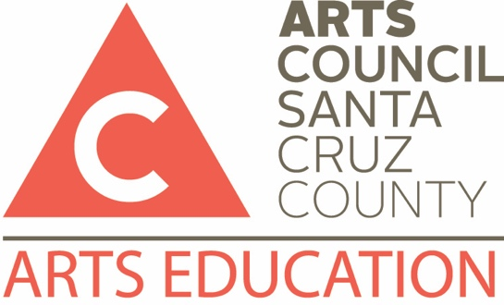

Teaching Artist Directory Participation Form

Please complete and return this form, as well as updated résumés and photos, to:
Sarah Brothers, Arts Education Manager
sarah@artscouncilsc.org

Visit http://www.artscouncilsc.org/teaching-artist-directory/ to check your current listing (listed alphabetically by first name).

APPLICANT INFORMATION

Name
SPECTRA Teaching Artist Community Teaching Artist or Arts Education Program
Discipline: Dance Music Theatre Visual Arts Literary Arts Multidisciplinary
Group name (if applicable)
Address
City |  |  | State |  | ZIP
Phone |  |  | Alternate Phone
Email
Website
Are you providing a biography? Yes No
Are you providing a photo to accompany your profile? Yes No
Are you available for after school programs? Yes No
Do you offer community-based classes/workshops too? Yes No
Do you have a CA Teaching Credential? Yes No
If yes, type and date:
Additional languages:

PROGRAM OFFERINGS – YOU MAY LIST UP TO 4 PROGRAMS

OPTION 1:
Program title:
Grade(s):
School Performance/Assembly Program Fees:
1 performance: $ | 2 consecutive performances: $ | 3 consecutive performances: $
Workshop/Residency Program Fees:
Hourly rate:
Are your fees negotiable? Yes No
Additional fees (kiln, materials, etc.): Yes No
Requires (classroom type, rehearsal time, etc.):
Brief Program Description and Learning Goals:
SPECTRA artists are expected to address and align their work, whenever possible, with the California Content Standards for the Visual and Performing Arts. (http://www.cde.ca.gov/ci/vp/)

OPTION 2:
Program title:
Grade(s):
School Performance/Assembly Program Fees:
1 performance: $ | 2 consecutive performances: $ | 3 consecutive performances: $
Workshop/Residency Program Fees:
Hourly rate:
Are your fees negotiable? Yes No
Additional fees (kiln, materials, etc.): Yes No
Requires (classroom type, rehearsal time, etc.):
Brief Program Description and Learning Goals:
SPECTRA artists are expected to address and align their work, whenever possible, with the California Content Standards for the Visual and Performing Arts. (http://www.cde.ca.gov/ci/vp/)

OPTION 3:
Program title:
Grade(s):
School Performance/Assembly Program Fees:
1 performance: $ | 2 consecutive performances: $ | 3 consecutive performances: $
Workshop/Residency Program Fees:
Hourly rate:
Are your fees negotiable? Yes No
Additional fees (kiln, materials, etc.): Yes No
Requires (classroom type, rehearsal time, etc.):
Brief Program Description and Learning Goals:
SPECTRA artists are expected to address and align their work, whenever possible, with the California Content Standards for the Visual and Performing Arts. (http://www.cde.ca.gov/ci/vp/)

OPTION 4:
Program title:
Grade(s):
School Performance/Assembly Program Fees:
1 performance: $ | 2 consecutive performances: $ | 3 consecutive performances: $
Workshop/Residency Program Fees:
Hourly rate:
Are your fees negotiable? Yes No
Additional fees (kiln, materials, etc.): Yes No
Requires (classroom type, rehearsal time, etc.):
Brief Program Description and Learning Goals:
SPECTRA artists are expected to address and align their work, whenever possible, with the California Content Standards for the Visual and Performing Arts. (http://www.cde.ca.gov/ci/vp/)

